New Business Manager Setup

How to Set Up a New Business Manager
This is the exact process for setting up a new Business Manager from scratch. Follow this step-by-step and you'll have a fully functional BM ready to run ads.

Step 1: Buy or Request Access to the Business Manager
- Go to the Facebook Business Manager Vendors List and buy a business manager OR request invitation access from a vendor
  - I recommend using https://proads.shop/
- Check your email and accept the invite to the business manager

Step 2: Invite the Team
Invite the following emails to the business manager:
- Invite your manager/founder (if you don’t know their email just ask them…)

Step 3: Remove External People
- Tag the team and wait for someone to join
- Once someone from the team has joined, remove all external people from the business manager (this includes the vendor who sold you the BM)
- If you're unable to remove the external accounts, email the vendor directly and tell them to leave

Step 4: Create Ad Accounts
- Go to Ad Accounts in the Business Manager
- Create as many ad accounts as it possibly lets you (should be 4-5 ad accounts)
  - IMPORTANT: Select USD currency when creating each ad account
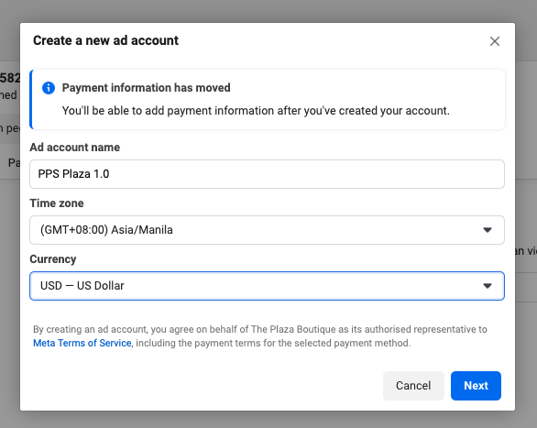
  - If prompted to add a payment method during creation, click EXIT (don't add payment yet)

Step 5: Add Ad Accounts to the Tracking Sheet
- Add the spare ad accounts to the BACKUP AD ACCOUNTS Google Sheet
- Mark them as "warming up" in the status column
  - Backup Ad Accounts

Step 6: Add Payment Method
- Go to Business Settings → Click the hamburger menu (three lines) → Billing & payments
- Add Managers payment method by following the exact navigation shown in the setup guide
- This MUST be done this specific way (don't just add it from the ad account level)
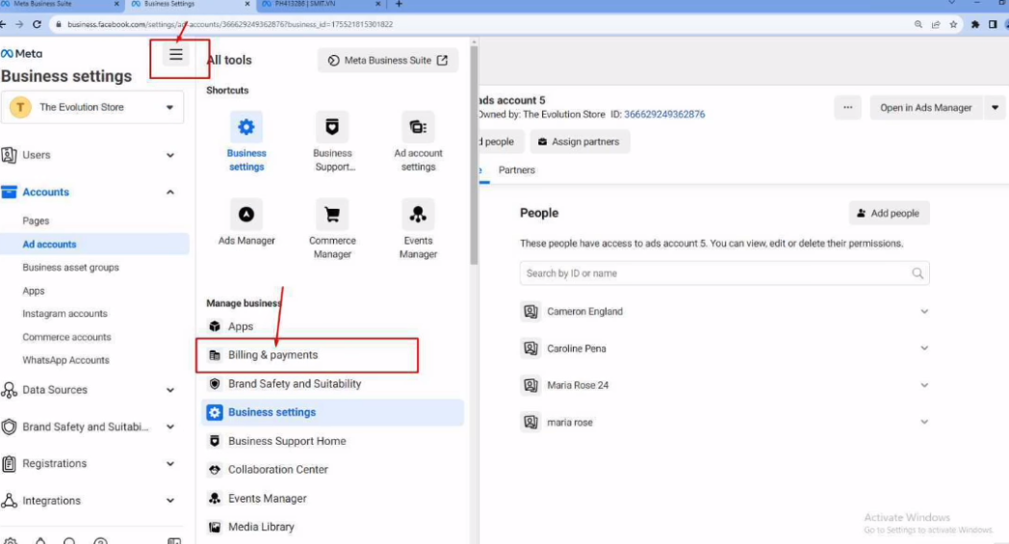

Step 7: WAIT 24 HOURS
DO NOT SKIP THIS STEP.

You need to wait 24 hours before setting up the engagement campaigns. This gives Facebook time to process the new ad accounts and reduces the risk of restrictions.

Step 8: Set Up Engagement Campaigns
After the 24-hour wait period:
- Set up an engagement campaign on $5/Day for each ad account
- Use the Engagement Campaign Import Link to import the pre-built campaign
  - Example Campaign To Import
- Set reminder on 5th day to turn off the campaigns
  - This makes sure all ad accounts are “warmed up” and you fully mitigate restriction issues

Step 9: Notify Manager on Day 5
- On the 5th day, notify your manager that the warmup is complete
  - Make sure to remove the card on file once the warmup campaigns are completed

Step 10: Update the Tracking Sheet
- Update the ad account status on the BACKUP AD ACCOUNTS doc to "open"
- These ad accounts are now ready to use if a client's account gets restricted

Quick Reference Checklist
Use this checklist to make sure you didn't miss anything:

- Bought/requested access to Business Manager
- Accepted invite via email
- Invited all team emails
- Removed all external people
- Created 4-5 ad accounts (USD currency, no payment method)
- Added ad accounts to BACKUP AD ACCOUNTS sheet (status: "warming up")
- Added Managers payment method via Billing & payments
- Waited 24 hours
- Set up $5/day engagement campaigns for each ad account
- Set reminder to turn off in 5 days
- Notified Managr on day 5
- Removed card on file
- Updated tracking sheet to "open"

